Release Notes

This release contains an application which was is created on WPF using MVVM pattern

This application was an assessment for me to develop by Synechron

Application contains 2 Screen

1. Welcome Screen: This screen is a splashscreen which contains some offer scrolling in storyboard along with a button “Get More Info”

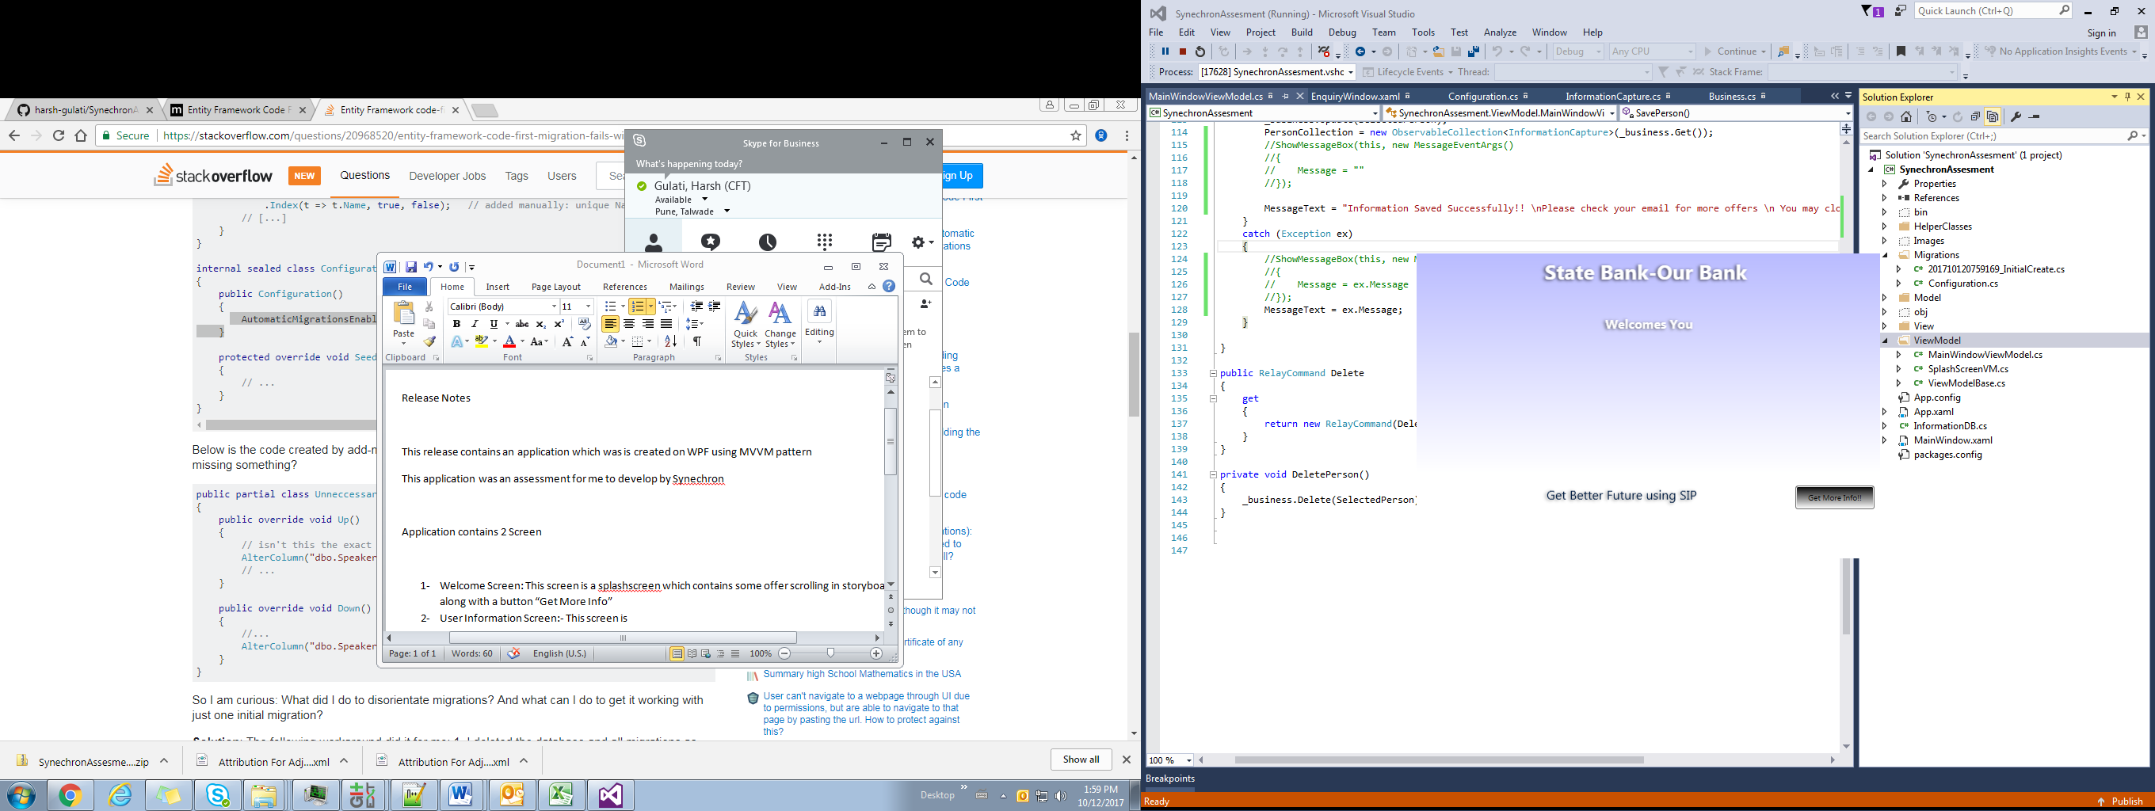

1. User Information Screen:- This screen is a dialog screen which is used to fetch information about the user & shows appropriate messages according to the action done

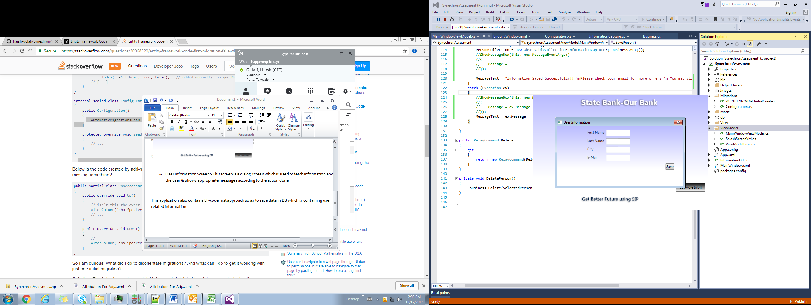

This application also contains EF-code first approach so as to save data in DB which is containing user related information.

**Known Issues on First start up**

On first start , you might see an error related to database while trying to run it in visual studio

Fix: - you need to run command in Package manager in order to fix this error

: - Open Package manager command prompt

Type –add-migrations

update-database

This will fix the issue, For more info you can visit this MSDN <https://msdn.microsoft.com/en-us/data/jj591621>

Future Scope:-

As this an assessment, futuristic approach can be providing more animation on the UI .

Also, maintaining proper validation messages on the popup.